Name:G SHIVANI
- Roll no : 2520090046

SKILL WEEK-1
Session -1
Task1: To Install Linux VM, Configure GCC, Setup Git Repository, Create Project Structure, Understand Shell Architecture, Build Initial Makefile.
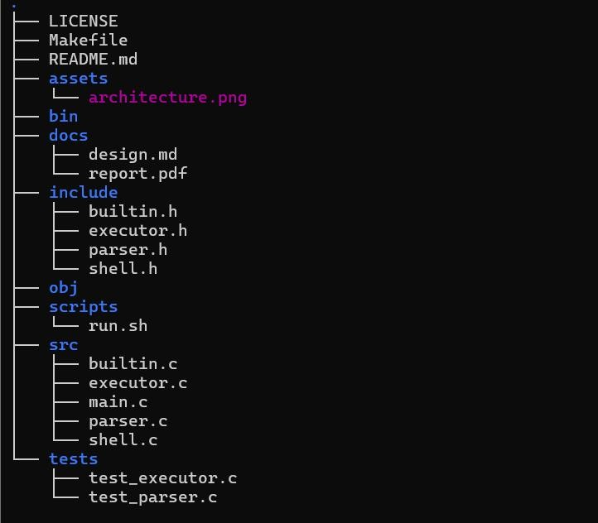

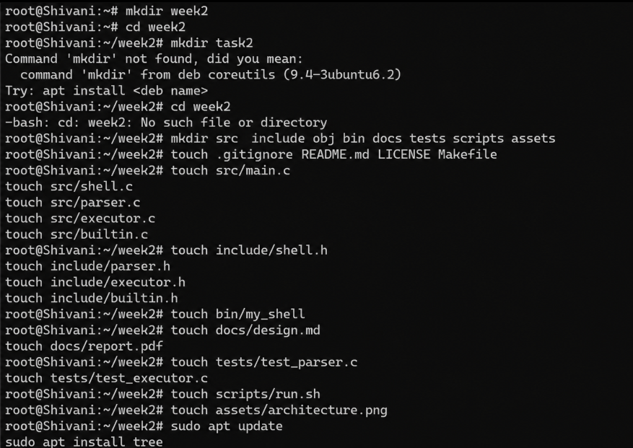

Observation: I explored the Linux development environment and practiced organizing a shell project into appropriate directories and files. I also learned the

role of GCC in compiling C programs and understood how Git helps in maintaining and tracking the project files. This activity helped me develop a clear understanding of how a software project is structured and managed systematically.
Task2: To Analyse process abstraction, execute fork(), understand exec() family, analyse parent-child relationships, inspect process tree, and practice system call tracing.
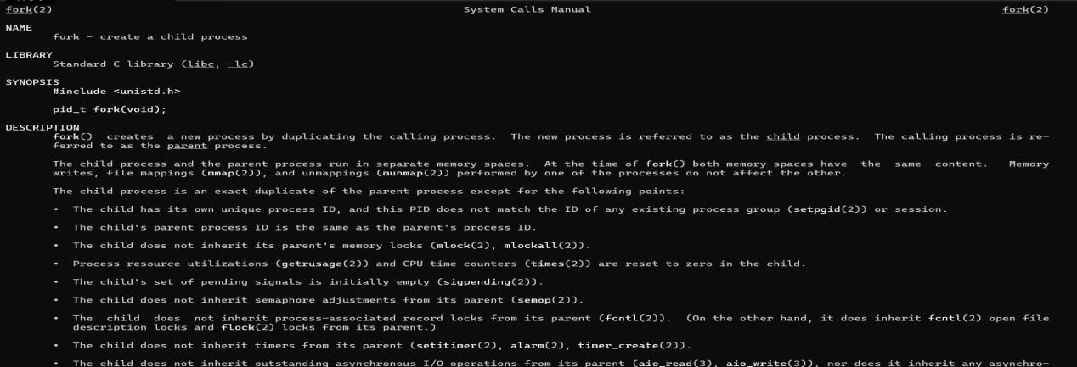

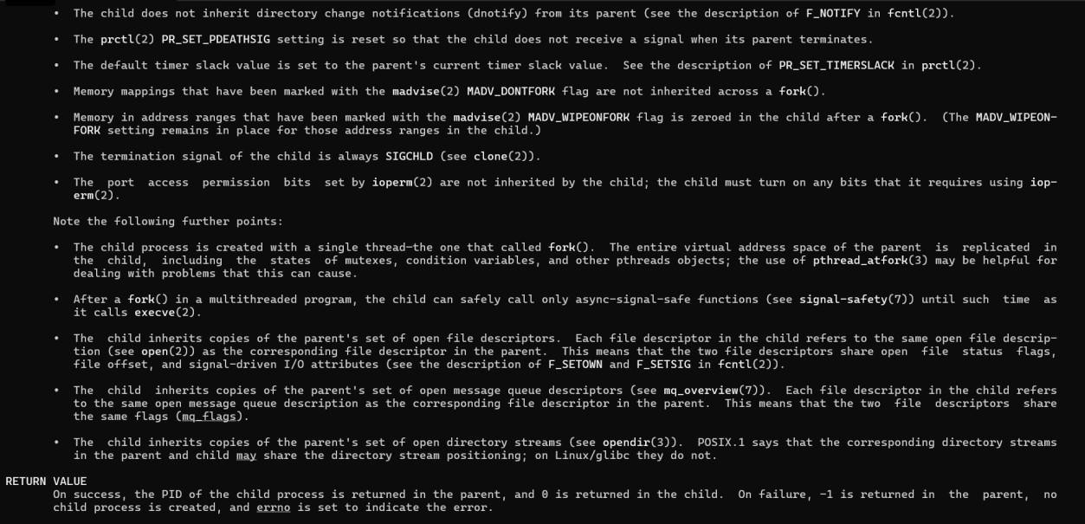
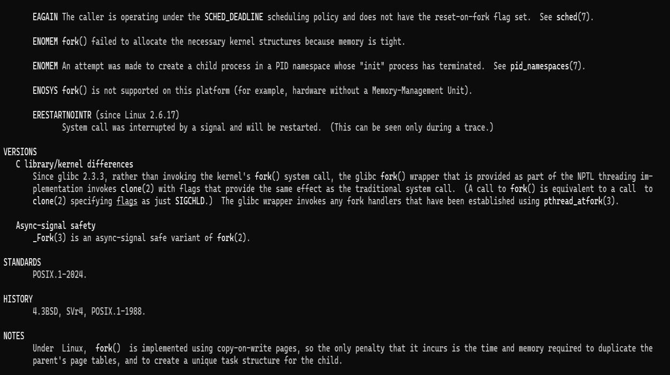
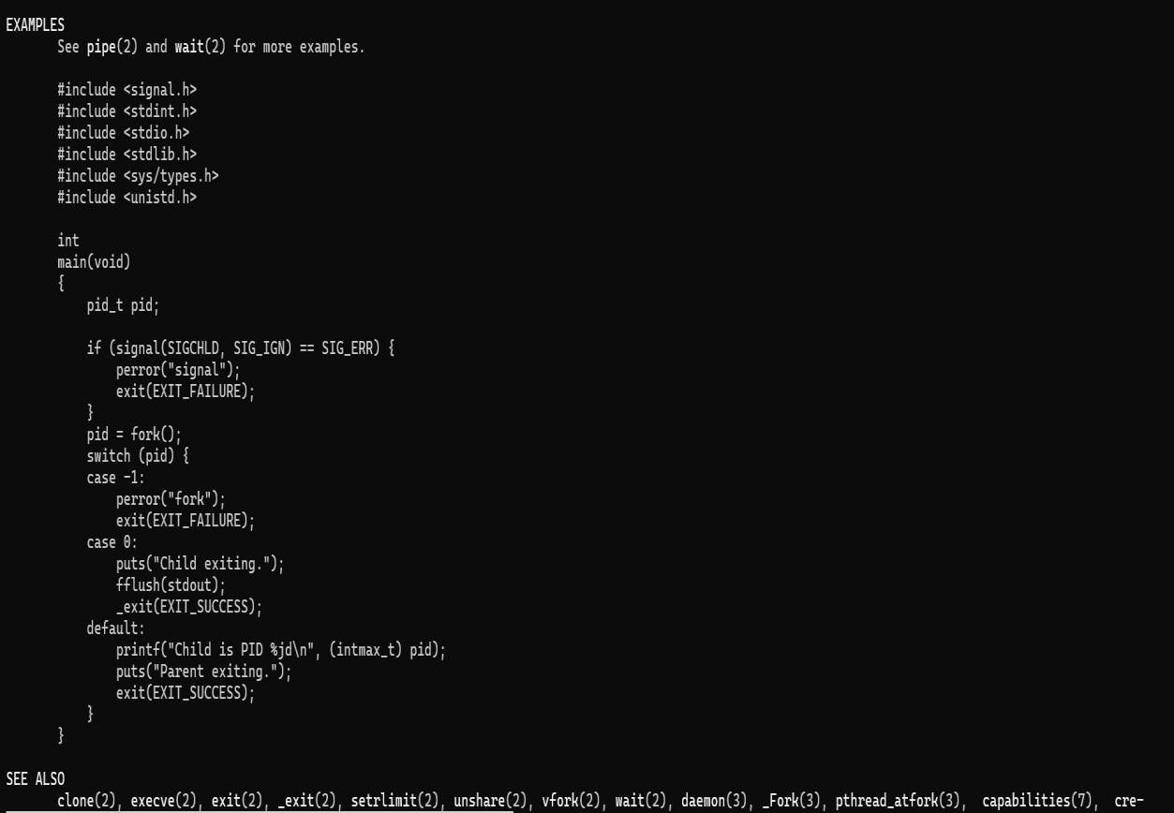

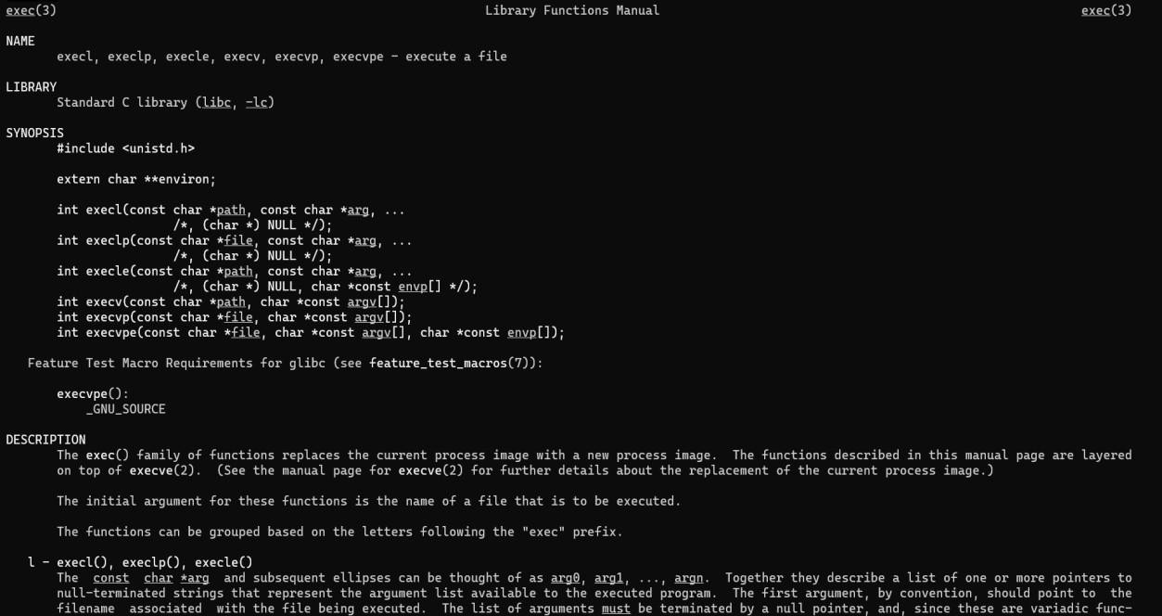
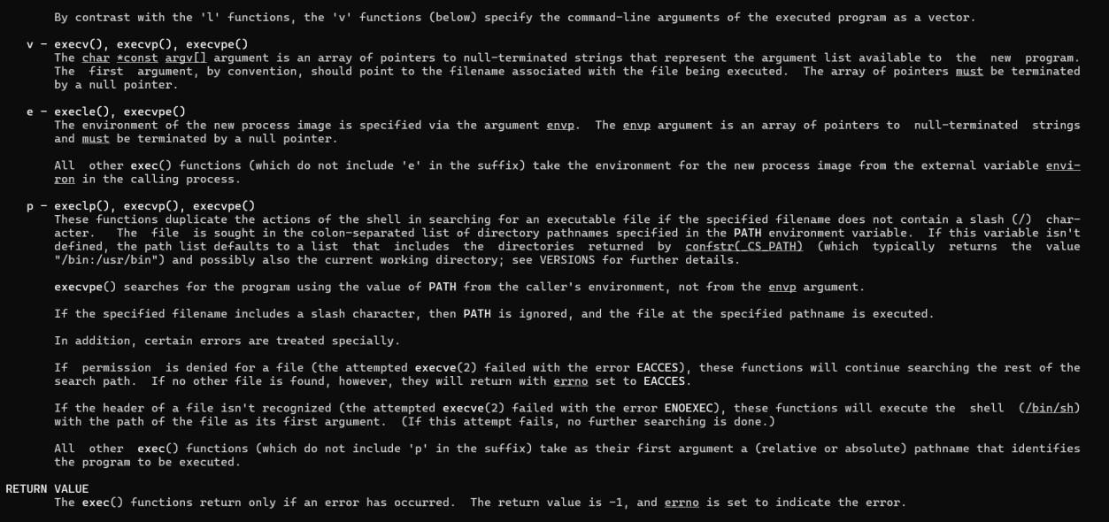
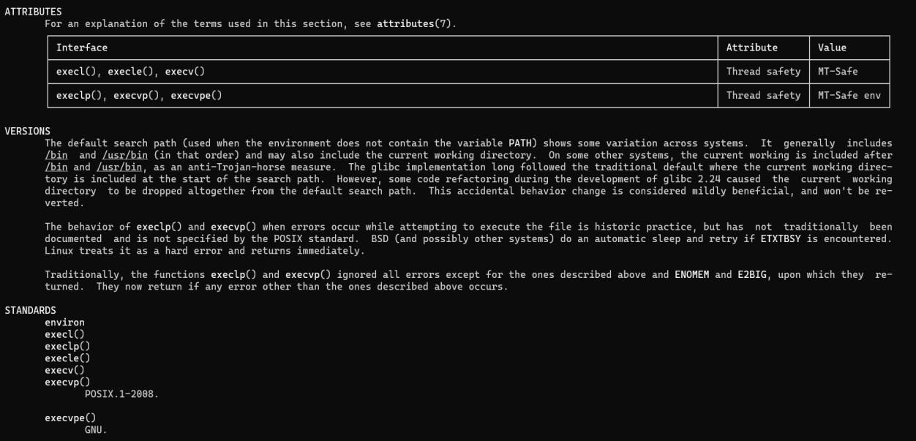

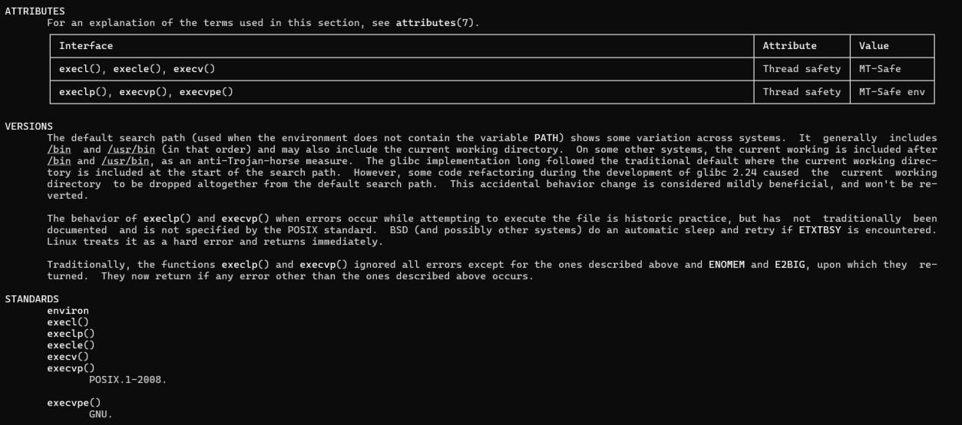
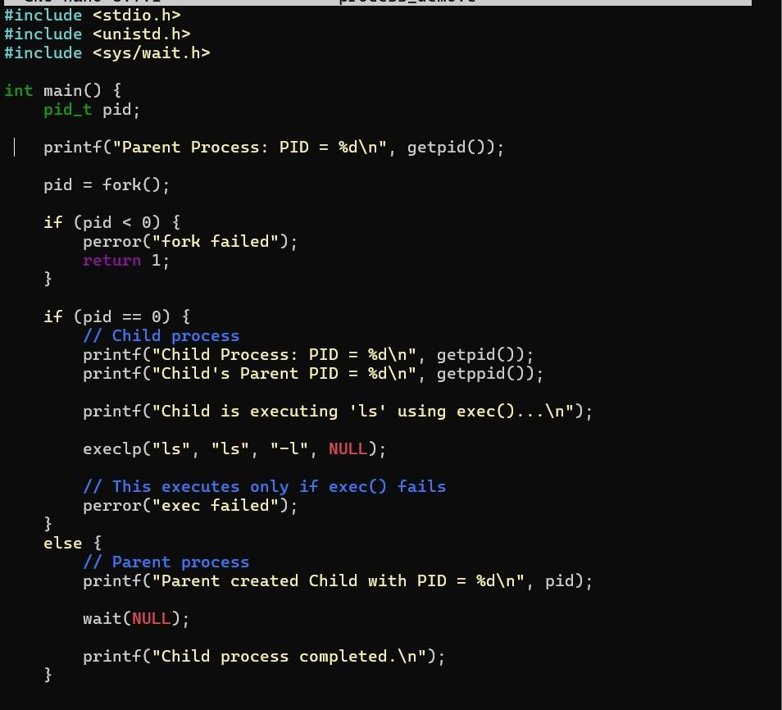

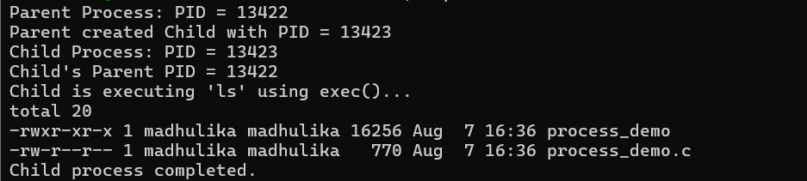

Observation: I gained practical knowledge of process management in the Linux operating system by studying process abstraction and the creation of new processes using the fork() system call. I understood how a parent process creates and manages a child process and how the exec() family of functions is used to replace the child process with a new program. I also inspected the process hierarchy using process-tree commands and used system-call tracing to observe the system calls performed during program execution. This practical helped me understand the working relationship between processes and how the operating system manages process creation, execution, and communication
Session -2
Task1: To Create Main Loop, Display Prompt, Read User Input, Handle Exit Conditions, Design Control Flow Diagram, and Test Interactive Loop.
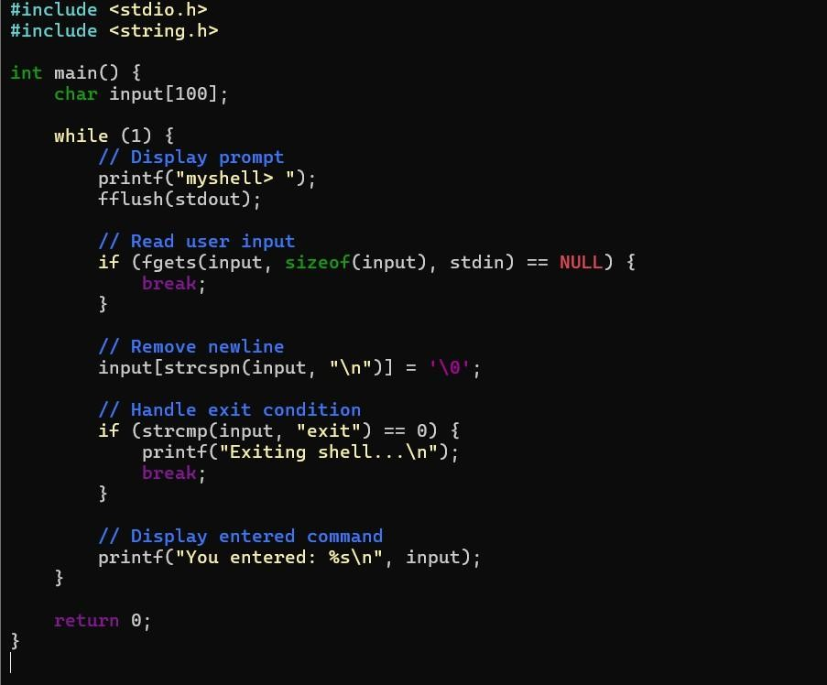

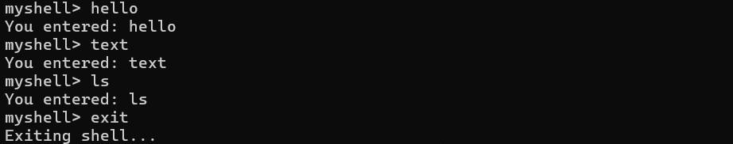
Observation: I learned how to develop and test an interactive command loop for a basic Linux shell. I understood how to display a prompt, accept and process user input, and continuously repeat the loop until an exit condition is encountered. I also gained practical knowledge of using conditional statements and loops to control program execution. This activity helped me understand the basic control flow of an interactive shell and how user commands are handled efficiently.
Task 2: Capture Keyboard Input, Handle Backspace, Process Enter Key, Manage Input Buffer, Support Multi-Character Commands, Test User Interaction
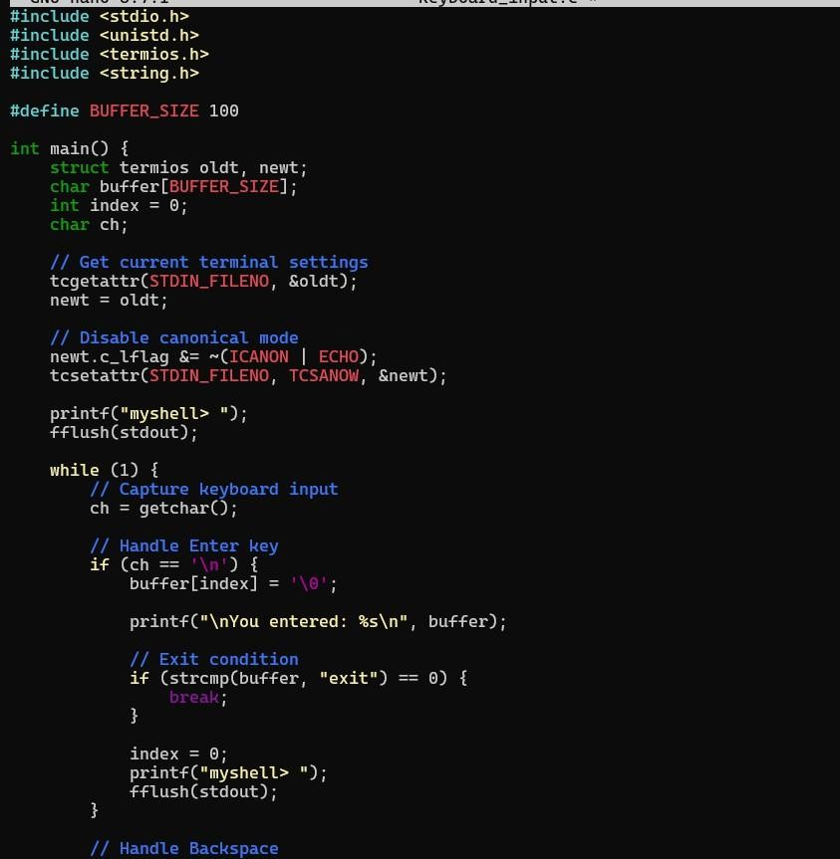

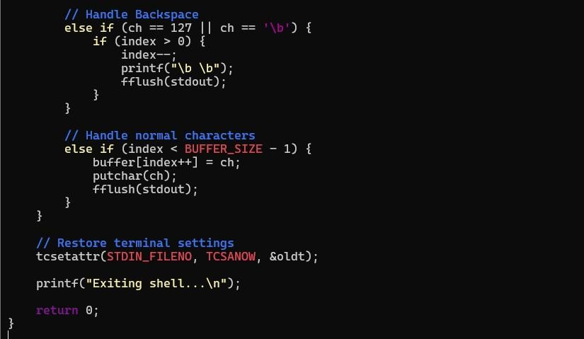

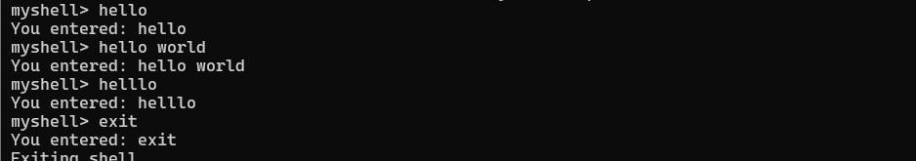
Observation: I learned how to capture and process keyboard input in an interactive shell environment using an input buffer. I understood how individual characters are stored and processed, how the Backspace key can be used to remove characters, and how the Enter key is used to submit the entered command. I also practiced handling multi-character commands and managing the input buffer efficiently. This task helped me understand how a command-line interface handles user interaction at the character level and how different keyboard inputs are processed within a shell program.

